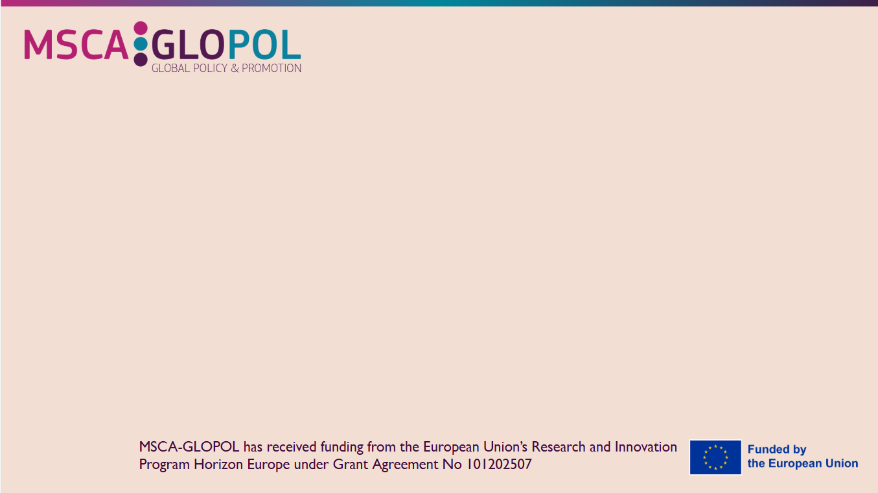

MSCA National Info Day in Algeria
University of Salah Boubnider Constantine 3
26 January 2026
Agenda

Venue: Université Salah Boubnider Constantine 3
Hybrid : Registration Link:
https://euconf-eu.zoom.us/webinar/register/WN_EQjQOUGQSnOWYKY8VracEQ

Aim of the Infoday:
This information session aims to boost awareness and engagement with the Marie Skłodowska-Curie Actions (MSCA) under Horizon Europe and to promote MSCA Doctoral Networks (DN) among relevant institutions in Algeria. MSCA funds excellent research and innovation and supports researchers at all career stages by providing new knowledge and skills through international mobility and exposure to different sectors and disciplines, thereby strengthening Europe’s long-term research and innovation capacity. As MSCA remains a relatively new programme for universities, public administrations, and academic and non-academic institutions in Algeria, this session seeks to raise awareness of its main schemes, in particular Doctoral Networks and Postdoctoral Fellowships, with a specific focus on the MSCA DN call opening on 16 December 2025. The event is organised in close cooperation with the Ministry of Higher Education and Scientific Research in Algeria, the European Commission’s Directorate-General for Education, Youth, Sport and Culture (DG EAC), and the MSCA-GLOPOL project funded by the European Commission. The working language of the event will be French.

Marie Skłodowska-Curie Actions (MSCA)
National Infoday – Algeria -
26 January 2026 – Monday, 09:00 – 12:30
Venue: Université Salah Boubnider Constantine 03
Hybrid Event
https://euconf-eu.zoom.us/webinar/register/WN_EQjQOUGQSnOWYKY8VracEQ
09:00 - 09:30 | Registration
09:30 - 09:40 | Welcome remarks  Dr. Samira CHADER  Sous-Directrice des Programmes de Coopération Universitaire et de Recherche.  Direction de la Coopération et des Echanges Universitaires  Ministère de l’Enseignement Supérieur et de la Recherche Scientifique
09:40 - 10:20 | Introduction of Horizon Europe in General  - Where to find Marie Skłodowska-Curie Actions in Horizon Europe  - Position of Algeria  Doctoral Networks Call  - 2026 Call details  - Minimal conditions for a consortium  - Opportunities for Institutions  - Financial contribution to the projects  Sohail LUKA (online)  Policy Officer, MSCA Unit, Directorate General for Education, Youth, Sport and Culture, European Commission
10:20 - 11:20 | - How to participate in a Doctoral Networks Call proposal via Participant Portal?  - How to find partners via MSCA Matchmaking Platform, F&T Portal, NCPs, and EURAXESS?  - How to write a proposal and checking the criteria (Excellence & Impact &Implementation)  - “Tips and Tricks” while drafting the proposal  Ahmed MAALEL (onsite)  Regional Liaison Officer, Tunisia, Algeria, Morocco & Support for Jordan  Cristina GOMEZ (online)  MSCA-GLOPOL Project management team
11:20 - 11:40 | Coffee Break
11:40 – 12:00 | Success Stories from Algeria: How to Achieve Excellence to Secure Funding?  Dr LATATI Mourad. University of Skikda
12:00 – 12:25 | Interactive Session – Q&A
12:25 – 12:30 | Closing Remarks

